Tuya access control operation
Code50
instructions V1.0
1.Specifications:
1.1Technical parameters:
Item | Value | Item | Value
Operating voltage | DC 12-24V | Storage | 1000users
Operating current | < 100mA | Card type | ID+IC dual band
Operating temperature | -20℃—60℃ | Relative humidity | 20%—80%
Weight | About 200g | Reading distance | 1－8CM
1.2Factory Default:
Item | Value | Item | Value
Authentication Mode | Card or Password(PIN) | Common PIN | None
Unlocking Duration | 5 S | Programming Password | 123456

1.3Light and Sound indicates:
Light: red and green
Light Description | Indicates
Red light flash every 2 sec(Slow flash) | Standby state
Green light flash every 0.5sec(Fast flash) | Pending further operation
Red light is always ON | Programming state
Green light is always ON | Unlocking state
Red and green light flash alternately | Restoring Factory Programming Password

Sound: beep
Sound Description | Indicates
1 short beep | Valid input
3 short beeps | Invalid input
1 long beep | Programming state
3 long beeps | Restoring Factory Programming Password
2.Installations Guide:
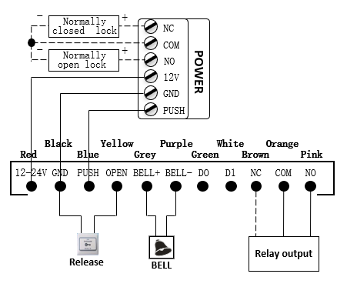

Remark:
If let Relay drive electric-lock, please connect a backward diode
with the lock’s “+” and “-” poles.

3. Programming Guide
3.1. Programming Guide: (Programming Password Default: 123456) Remark: All password can be 3~6 digits.
Programming Item |  | Press key and swipe card operations | Remark
Basic  Function | Change Programming Password (Pro.PW) | # Pro.PW # 0 new Pro.PW # new Pro.PW # | If Pro.PW lost, perform 3.2 to reset to Factory Default (123456)
Basic  Function | Add user card | # Pro.PW # 1 swipe cards # | If add series cards, swipe cards continuously
Basic  Function | Configure Common PIN | # Pro.PW # 21 new Common PIN # | Common PIN is only one, Unlocking method : Enter Common PIN then press [#]
Basic  Function | Delete all users | # Pro.PW # 40 0000 # | Delete all cards and PIN except Common PIN
Basic  Function | Delete user by swiping card | # Pro.PW # 41 swipe cards # | If delete series cards, swipe cards continuously
Expand Function | Add user by input User ID | # Pro.PW # 22 4-digit User ID swipe card # | Add user card or PIN by user’s ID. User ID must be 4 digits and cannot be reused (3 beeps means reused and need to enter a new). If add series users repeat the operation. More about User ID see 3.3
Expand Function | Add PIN | # Pro.PW # 23 4-digit User ID new PIN #
Expand Function | Delete user by User ID | # Pro.PW # 42 4-digit User ID #
Expand Function | Delete user by card No. | # Pro.PW # 43 card No. # | Card No. is 10-digit or 8- digit, device auto-identify
Expand Function | Configure Unlocking Duration | # Pro.PW # 5 XX # | XX is 2-digit (00~99). If XX is 00, Unlocking Duration is 0.2s
Expand Function | Configure Authentication Mode | # Pro.PW # 6 XX # | XX can be 02(Card or PIN)/03(Card & PIN)
Expand Function | Backlight setting | # Pro.PW # 8 XX # | XX can be 01/02/03 (Normal ON / Normal OFF / Auto)
Expand Function | Reset Factory Default | # Pro.PW # 8 99 # | Except Programming Password and Manager Card
3.2 How to reset to Factory Programming Password (123456)
Step1, Turn off power and connect OPEN and GND terminal. Turn on power then there is 3 long beeps with green and red light flashing alternately.
Step2, Turn off power, disconnect OPEN and GND terminal. Turn on power again. Initializing Programming Password is completed.
3.3, Use ID explanation
User ID is 4-digit number from 0001 to 9999. There is no User ID for the users added by command [1]. Perform command [40] to clear all User ID.
3.4, How to change PIN
Swipe card or press PIN to unlock within 5s press [#] for 3s until the green light flash fast, then press [new PIN # new PIN #], the new PIN changed successfully with a long beep.
3.5, Authentication Mode for Card & PIN function
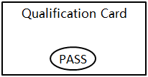
Setp1, When Authentication Mode is [Card or PIN] (factory default), according to the step 3.4 to configure the PIN of the card.
Setp2, Press [# Programming Password # 603 #] to configure Authentication Mode to be [Card & PIN].
Setp3, Swipe user’s card with green light fast flash then input [PIN #] with green light normally ON, the door opened successfully.
3.6 Door open function description:
When the credit card or password is normally opened, press the 7, 9 digit key to keep the door open. When the door is always open,
only once the credit card, password, or the door button is opened again, the exit is always open.

