Access Controller Use Manual V2.0
Code12
1.Specifications:
1.1Technical parameters:
Item | Value | Item | Value
Operating voltage | DC 12V±10% | Storage | 1000
Operating current | < 100mA | Card type | EM(standard)  /Mifare(optional)
Operating temperature | 0℃—60℃ | Reading distance | 1－5CM
Weight | 350g | Dimensions | 130*58*24mm

1.2Factory Default:
Item | Value | Item | Value
Authentication Mode | Card or Password(PIN) | Common PIN | None
Unlocking Duration | 5 S

1.3Light and Sound indicates:
Light: red and green
Light Description | Indicates
Red light flash every 2 sec(Slow flash) | Standby state
Green light flash every 0.5sec(Fast flash) | Pending further operation
Red light is always ON | Programming state
Green light is always ON | Unlocking state
Red and green light flash alternately | Restoring Factory Programming Password

Sound: beep
Sound Description | Indicates
1 short beep | Valid input
3 short beeps | Invalid input
1 long beep | Programming state
3 long beeps | Restoring Factory Programming Password

2.Installations Guide:
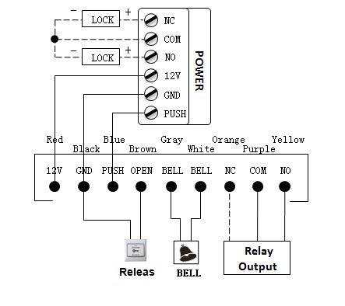

Remark:
If let Relay drive electric-lock, please connect a backward diode
with the lock’s “+” and “-” poles.

3. Programming Guide
3.1 Detailed Programming Guide：
Programming Password Default: 123456, all password can be 3~6 digits
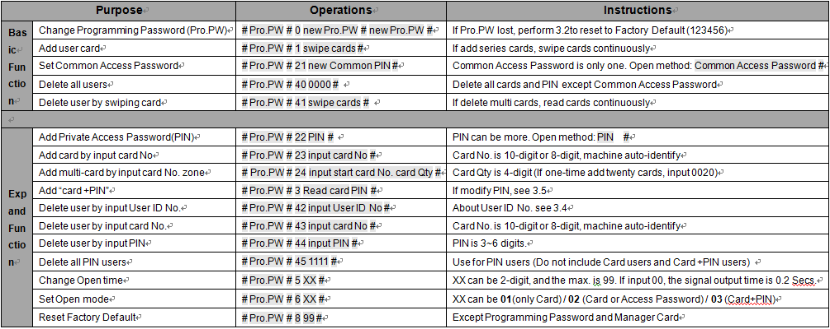

3.2 To reset to Factory Programming Password（123456）
Step1、Turn off power and connect bin 2&3 of RST(S1)。
Step2、Turn on power and buzzer gives 3 long buzz with green light flash fast。
If need to set Manager Card, now read two empty cards first one as Manager Add Card and Second one as Manager Delete Card with red light flashing and continuous short buzz .
Step3、Turn off power, disconnect bin2&3 and connect bin 1&2 of RST。
Step4、Turn on power again.
3.3 How to use Manager Card – MAC&MDC
To add a card user in standby mode: read MAC read new cards read MAC
To delete a card user in standby mode: read MDC read registered cards
read MDC

To delete all users in standby mode: read MDC read MAC read MDC
Remark: User cards can be added or deleted continuously.
3.4 User ID No. explain
User ID is auto-generating 4-digit number started at 0001. The number increases with adding user one by one and ignores deleting user.
Common Access Password has no ID.
3.5 How to change PIN (When open mode: card+ PIN)
After reading card and input corresponding PIN to open the door,
within 5 seconds, long press # until the green light flash fast， and
then input new PIN # new PIN # , new PIN changed successfully
with a long buzz.

